 | SMART COMPETITION 2016
 |  | EMAIL ADDRESS | PHONE
TEAM NAME:
SCHOOL NAME:
SCHOOL ADDRESS:
TEACHER’S NAME:
MENTOR’S NAME:
STUDENT’S NAMES:

INSERT TEAM PICTURE:
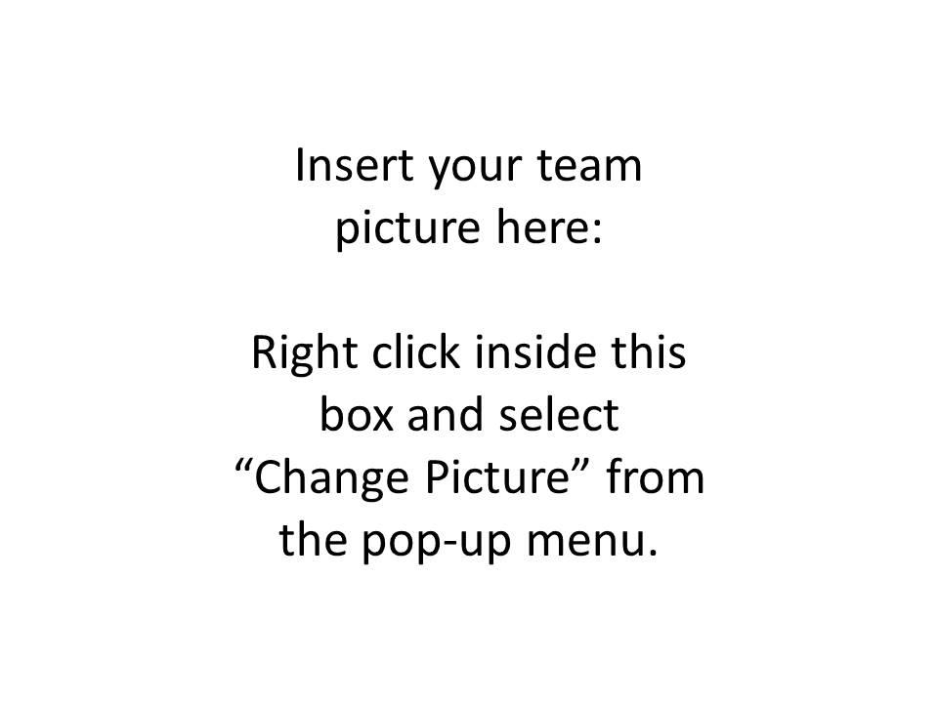

 | DAILY NOTES AND BACKGROUND RESEARCH
DATE | DATA ENTRY
1/1/2016 | AS YOU MAKE YOUR LOGBOOK ENTRY, THE TEXT WILL AUTOMATICALLY WORD-WRAP AND THE TABLE CELL WILL INCREASE IN SIZE TO ACCOMMODATE THE ENTRY.  IN ADDITION TO TEXT, IMAGES, GRAPHS, CHARTS, RESEARCH INFORMATION, COPIES OF DETAILED REPORTS, ETC. CAN BE PART OF THE LOGBOOK ENTRY.  WHEN YOU COME TO THE END OF THE TABLE, THE TAB KEY WILL CREATE ANOTHER LINE OF INPUT CELLS FOR THE NEXT ENTRY.

General Notes:
- Fill out form recording daily activities.
- Insert charts, graphs, pictures that illustrate research and data that reflects your work.
- Reflect planning assignments, who has what responsibilities.
- The logbook should contain all activities performed by the team members.

